# Design Thinking

## Persona

### Student

Jane is a master student with a Bachelor degree in business administration. She has average computer skills, so she needs some technical support when she has to deliver assignments for her lectures for which she needs to use several applications. She also needs help to get access for student portal where all her lecture’s content are published.

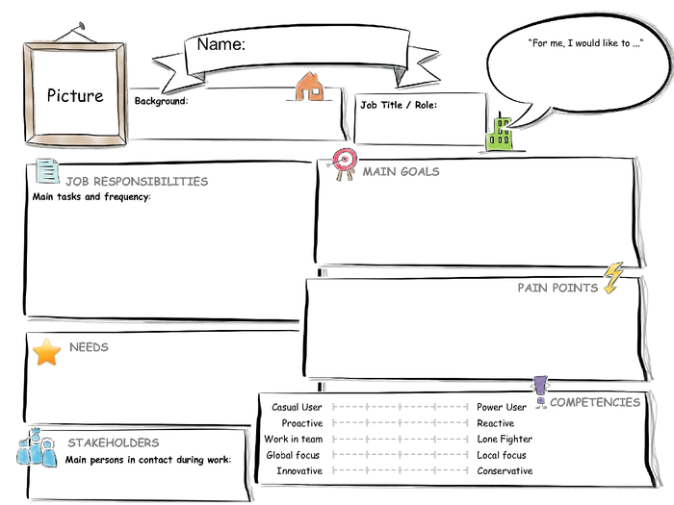

Bachelor degree in business administration, first semester in master program, average computer skills

I would like to get technical support during my master program

Support team member

I need support to prepare projects with software tools, to access online student portal

Get lecture content,  
deliver assignments/lecture projects on time,  
pass exams

Master Student

Jane

Lack of technical skills to deliver assignments/projects

Attend lectures on time,  
prepare and deliver assignments/projects,   
sign in for exams, c  
heck exam results

Figure 1 Student Persona (Bob Caswell, 2015)

### Support Team Member

Marc is a member of support team. He studied information systems and has 3 years of work experience in IT departments of several companies. He would like to achieve high performance on delivering support on time. To reduce his response time to the requests, a dashboard with a list of open tickets would be very helpful for him. The strongest pain point for him is the communication with the requester. He needs a platform where he can see all communication history to follow up the case easier.



Students,  
Support team manager

Resolve issues of students within 24 hours

Lack of sufficient information about the support needed, lack of notification on time.

Support Team Member

Studied information systems, worked 3 years in it department, very good computer skills

I would like to achieve high performance on delivering support on time to students

I need a dashboard to see new and open tickets, a platform that I can contact the requester.

Marc

Provide support/information to students

Figure 2 Support Team Member Persona (Bob Caswell, 2015)

### Support Team Manager

Albert is the support team manager. He studied information systems and worked for 8 years in IT and support departments of several companies. His goal is to improve efficiency and effectiveness of support team. He needs a real time insight for overdue requests so that he can assign them manually to avoid late support. He spends much time to create performance reports so analytics will facilitate his job to review performance of his team.



Studied information systems, worked 8 years in it and support departments, very good computer and management skills

I need to reduce response time for support requests, I need realtime insight of support team activities

Support team members,  
Students

Support Team Manager

I would like to improve efficiency and effectiveness of support team

Reduce response time for support requests,  
Reduce overdue support requests,

Improve support for students

Albert

Excessive time spent to create reports of support team activities,  
Late insight into overdue support requests

Oversee daily support activities, handle overdue support requests,  
supervise support team members,  
manage support team performance

Figure 3 Support Team Manager Persona (Bob Caswell, 2015)

## Requirement Analysis Interviews

### Student Interviews

### Julia Müller

*Q1: Could you please give us brief information about yourself?*

A1: I’m a Bachelor student in Business Administrations. Since this is my first semester, I’m very new to the university.

*Q2: Are there any difficulties that you are facing during your studies which you need to get support for?*

A2: Yes, I need support for mostly technical stuff. Like installing new software or accessing online sources for my lectures.

Q3: How do you get support?

A3: Mostly I try to get help from fellow students, but since we all started new this semester, it is hard to find real solutions together. We need help from someone who is experienced on our issues. I used the support mail group several times.

*Q4: Is the existing support mail group sufficient for you? In which ways do you think it could be improved?*

A4: I sent several questions to get help. At the end, they helped me but it took too long and I couldn’t submit my paper on time due to late support. A real system would be more sufficient. In that way, I can see the status of my request and if anyone started working on it.

*Q5: What other features do you think a support system should have?*

A5: Maybe a page like “frequently asked questions”. So that we can find answers to the questions which were asked before and it will take less time to solve our issues.

### Mateo González

*Q1: Could you please give us brief information about yourself?*

A1: I’m an Erasmus student coming from Spain. I study Statistics.

*Q2: Are there any difficulties that you are facing during your studies which you need to get support for?*

A2: Even though we had orientation sessions, which gave us information about school and our studies, sometimes I still have questions regarding administrative subjects, because I’m not familiar with German education system.

*Q3: How do you get support?*

A3: I go to the student office and ask them. Sometimes they can provide help to me but sometimes they suggest me to contact someone else.

*Q4: Is the existing support mail group sufficient for you? In which ways do you think it could be improved?*

A4: I heard about it, but I didn’t use it so far. Actually I don’t know in which areas they provide support and if my questions would be relevant to ask them. Instead of a mailing group, an online system would be better, I guess. Maybe some information about the system, showing what for we can use it, would make it easier.

*Q5: What other features do you think a support system should have?*

A5: It would be very helpful if we could chat with support team.

### Jasmin Neumann

*Q1: Could you please give us brief information about yourself?*

A1: I’m 30 years old and study Master of Computer Science. It’s my last semester, I started working on my Master thesis.

*Q2: Are there any difficulties that you are facing during your studies which you need to get support for?*

A2: At the beginning of my Master program, the most difficult part was for me to complete assignments for my lectures. Most of them required some practice on new databases, applications or frameworks which I had no experience before.

*Q3: How do you get support?*

A3: I searched a lot in internet, tried to find online tutorials. Sometimes I asked students who were studying in later semesters. But all these ways costed me too much time and effort. Sometimes I couldn’t find right solutions to complete my assignments in a better way.

*Q4: Is the existing support mail group sufficient for you? In which ways do you think it could be improved?*

A4: I use it but I can’t say it’s a life saver. First of all, it takes time to get an answer and since I can’t see if someone is working on my issue, I can’t count on it and stop searching other sources for support.

*Q5: What other features do you think a support system should have?*

A5: Different category types. For example, if I submit an issue, I should choose to which category it is related to and based on the chosen category, related support person should help me. This might cause to save time.

### Support Team Member Interviews

### Andreas Höfer

*Q1: Could you please give us brief information about yourself?*

A1: I’m 26 years old and have a Bachelor’s degree in Computer Science. I’m working part-time in the support team for the university.

*Q2: What are the major difficulties that you are facing during your work?*

A2: The biggest pain point is to decide with which issue to start. Without reading every new email, I cannot know what the issue is related to or if it is an urgent case.

*Q3: How do you share the issues with the other team members?*

A3: We set some rules based on the words in the subject of the mails. Regarding these words, mails are forwarded to specific members who are experienced on those subjects. The rest of the mails, we read and decide individually.

*Q4: Would it be easier for you to work with a ticketing system? Which features would you like to have in this system?*

A4: Sure it would help a lot. First of all I would like to see open issues as a list. When I start working on a specific one, my colleagues should be informed that I’m working on it, so that I don’t need to inform them separately and they don’t work on the same issue.

### Helena Wassermann

*Q1: Could you please give us brief information about yourself?*

A1: I’m a member of support team since 2 years and responsible for administrative subjects.

*Q2: What are the major difficulties that you are facing during your work?*

A2: For me the major challenge is to provide support on time. Most of the times, the students ask questions about official documents that they need or applications which they need to complete in a specific period of time and I need to help them before they are too late.

*Q3: How do you share the issues with the other team members?*

A3: It is mostly manual work. Even though we have some rules set in our mail program, we need to read them and decide if it is related to our own area.

*Q4: Would it be easier for you to work with a ticketing system? Which features would you like to have in this system?*

A4: It would definitely help a lot. We can sort open tickets based on their priority and category.

### Sven Günther

*Q1: Could you please give us brief information about yourself?*

A1: I work in the support team since the beginning of this year and responsible for authorization subjects.

*Q2: What are the major difficulties that you are facing during your work?*

A2: I receive same or very similar questions several times and providing the same solution repeatedly.

*Q3: How do you share the issues with the other team members?*

A3: We share them manually. It requires a big communication traffic.

*Q4: Would it be easier for you to work with a ticketing system? Which features would you like to have in this system?*

A4: Yes and If this ticketing system would have a separate page where we can provide ready solutions, it would make my work a lot easier. The students can first search on this page and if they cannot find answers, they can ask us anytime.

### Support Team Manager Interviews

### Michael Schneider

*Q1: As a support team manager, what are the difficulties you are facing during your work processes?*

A1: One of my major responsibilities, as a support team manager, is to reduce response time of support requests. To achieve this goal, I need to follow my team’s performance very closely. But I’m spending excessive time to create performance reports manually.

*Q2: Based on your experiences, which features for your role are mostly needed in a support ticketing system?*

A2: Analytics are definitely needed. I need reports and graphics to display each team member’s performance. Filtering the results by ratings would be also helpful.

### Sophia Schumacher

*Q1: As a support team manager, what are the difficulties you are facing during your work processes?*

A1: Overdue tickets are the biggest pain point of my work. Most of the negative feedback that we receive from students are related to overdue support.

*Q2: Based on your experiences, which features for your role are mostly needed in a support ticketing system?*

A2: I would like to have a list of open tickets which are overdue and have the possibility to assign them to team members.

### Peter Weber

*Q1: As a support team manager, what are the difficulties you are facing during your work processes?*

A1: My performance is related to my team’s performance. This means I need to have an insight of their workload and also of the tickets which are waiting since for a while.

*Q2: Based on your experiences, which features for your role are mostly needed in a support ticketing system?*

A2: Reporting is the most important feature I need for my job. I need analytics to have an overview of my team activities.

## User Stories

|  |  |
| --- | --- |
| **Epic : Search predefined support solution** | |
| US1 | As a student, I want to search for support solutions by text. |
| US2 | As a student, I want to search for support solutions by their categories. |
| US3 | As a student, I want to search for support solutions by their ratings. |
| **Epic : Create new ticket** | |
| US4 | As a student, I want to create a new ticket with only short description and category. |
| US5 | As a student, I want to create a new ticket with attachments. |
| US6 | As a student, I want to create a new ticket with a specific priority. |
| **Epic : List my tickets** | |
| US6 | As a student, I want to see my tickets as a list. |
| US7 | As a student, I want to filter my tickets by their categories, priorities, support team member. |
| US8 | As a student, I want to edit my existing ticket. |
| US9 | As a student, I want to delete my existing ticket. |
| US10 | As a student, I want to receive an email notification when a response sent for my ticket. |
| US11 | As a student, I want to respond to the support team via my ticket. |
| US12 | As a student, I want to confirm the solution provided. |
| US13 | As a student, I want to give feedback and rating about the provided support for my ticket. |
| **Epic : Create predefined support solution** | |
| US13 | As a support team member, I want to create, edit and delete support solution categories. |
| US14 | As a support team member, I want to create, edit, delete predefined support solutions by text. |
| US13 | As a support team member, I want to categorise predefined support solutions. |
| US14 | As a support team member, I want to add images, attachments to the predefined support solutions. |
| **Epic : Provide Support Solution** | |
| US15 | As a support team member, I want to see a list of open tickets. |
| US16 | As a support team member, I want to assign specific categories to my account. |
| US17 | As a support team member, I want to receive an email notification when a ticket with a category specified for my account is created. |
| US16 | As a support team member, I want to have the possibility to ask questions to the ticket owner via ticket. |
| US17 | As a support team member, I want to resolve tickets. |
| **Epic : List overdue tickets** | |
| US18 | As a support team manager, I want to have a list of overdue tickets. |
| US19 | As a support team manager, I want to filter overdue tickets by their creation dates, categories and priorities. |
| **Epic : Analytics** | |
| US20 | As a support team manager, I want to have analytics phs which display team performance by number of open tickets and team members. |
| US21 | As a support team manager, I want to have analytics which display team performance by number of raitings and team members. |
| US22 | As a support team manager, I want to have reports which will be generated based on the fields I choose. |

## Experience Maps

### Student

A student needs the content of his lecture. To reach the content he needs access to student portal. He thinks of getting the content from a classmate but decides to ask for access to support team, because he will need it for the rest of his studies. He is concerned of being already late and considers talking to the teacher. After creating a new ticket in the support system, he waits for a response. After several minutes, he receives a response which describes how to get access to the portal.

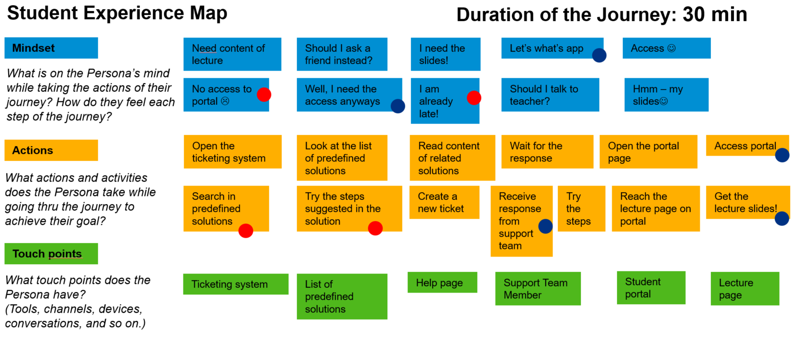

Figure 4 Student Experience Journey (Bob Caswell, 2015)

### Support Team Member

Support team member logs in to the support ticketing system and displays the list of open tickets. In some cases he needs extra information from the requester, so he sends the ticket back to the requester with his question and waits for his response to solve the issue. When he has all necessary information, he sends the solution to the requester and waits for his confirmation.

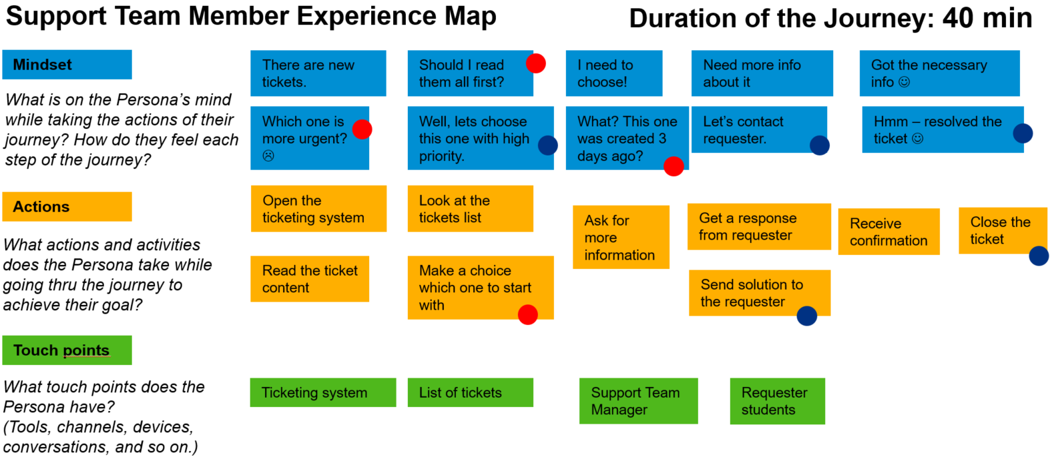

Figure 5 Support Team Member Experience Journey (Bob Caswell, 2015)

### Support Team Manager

Support team manager logs in to the support ticketing system. He displays the list of overdue tickets and assigns them to the available support team members. To view performance results of the team he displays the analytics.

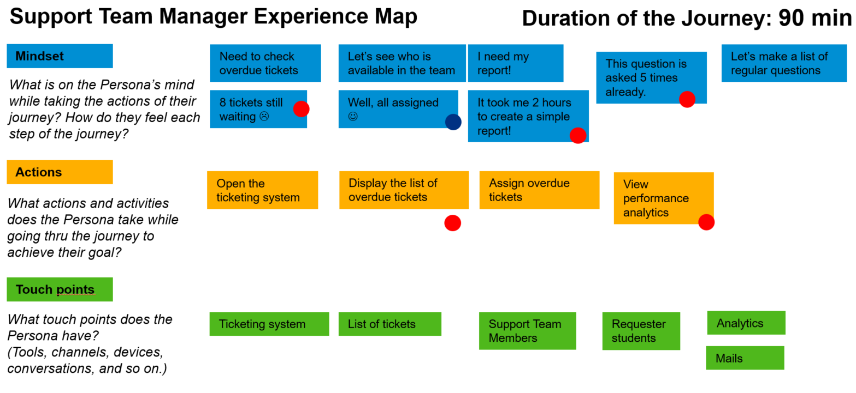

Figure 6 Support Team Manager Experience Journey (Bob Caswell, 2015)

## Task Mapping

|  |  |
| --- | --- |
| US1 | As a student, I want to search for support solutions by text. |
| US2 | As a student, I want to search for support solutions by their categories. |
| US3 | As a student, I want to search for support solutions by their ratings. |
| US4 | As a student, I want to create a new ticket with only short description and category. |
| US5 | As a student, I want to create a new ticket with attachments. |
| US6 | As a student, I want to create a new ticket with a specific priority. |
| US6 | As a student, I want to see my tickets as a list. |
| US7 | As a student, I want to filter my tickets by their categories, priorities, support team member. |
| US8 | As a student, I want to edit my existing ticket. |
| US9 | As a student, I want to delete my existing ticket. |
| US10 | As a student, I want to receive an email notification when a response sent for my ticket. |
| US11 | As a student, I want to respond to the support team via my ticket. |
| US12 | As a student, I want to confirm the solution provided. |
| US13 | As a student, I want to give feedback and rating about the provided support for my ticket. |
| US13 | As a support team member, I want to create, edit and delete support solution categories. |
| US14 | As a support team member, I want to create, edit, delete predefined support solutions by text. |
| US13 | As a support team member, I want to categorise predefined support solutions. |
| US14 | As a support team member, I want to add images, attachments to the predefined support solutions. |
| US15 | As a support team member, I want to see a list of open tickets. |
| US16 | As a support team member, I want to assign specific categories to my account. |
| US17 | As a support team member, I want to receive an email notification when a ticket with a category specified for my account is created. |
| US16 | As a support team member, I want to have the possibility to ask questions to the ticket owner via ticket. |
| US17 | As a support team member, I want to resolve tickets. |
| US18 | As a support team manager, I want to have a list of overdue tickets. |
| US19 | As a support team manager, I want to filter overdue tickets by their creation dates, categories and priorities. |
| US20 | As a support team manager, I want to have analytics phs which display team performance by number of open tickets and team members. |
| US21 | As a support team manager, I want to have analytics which display team performance by number of raitings and team members. |
| US22 | As a support team manager, I want to have reports which will be generated based on the fields I choose. |